**Build and Installing CARLA on Linux**

Refer to: <https://carla.readthedocs.io/en/latest/build_linux/>

**-1 system check**

**Requirements**

System specifics

* Ubuntu 18.04. CARLA provides support for previous Ubuntu versions up to 16.04. However proper compilers are needed for UE to work properly. The required dependencies for both Ubuntu 18.04 and previous versions are listed below. Make sure to install the ones corresponding to the system.
* 30GB disk space. Installing all the software needed and CARLA itself will require quite a lot of space, especially Unreal Engine. Make sure to have around 30/50GB of free disk space.
* An adequate GPU. CARLA aims for realistic simulations, so the server needs at least a 4GB GPU. A dedicated GPU is highly recommended for machine learning.
* Two TCP ports and good internet connection. 2000 and 2001 by default. Be sure neither the firewall nor any other application block these.

**-2 Dependencies**

CARLA needs many dependencies to run. Some of them are built automatically during this process, such as Boost.Python. Others are binaries that should be installed before starting the build (cmake, clang, different versions of Python and much more). In order to do so, run the commands below in a terminal window.

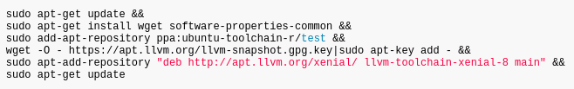

**Type this into your command line first (bear in mind, it is one line, not multiple lines):***sudo apt-get update && sudo apt-get install wget software-properties-common && sudo add-apt-repository ppa:ubuntu-toolchain-r/test && wget -O - https://apt.llvm.org/llvm-snapshot.gpg.key|sudo apt-key add - && sudo apt-add-repository "deb http://apt.llvm.org/xenial/ llvm-toolchain-xenial-8 main" && sudo apt-get update*

choose Yes or type ENTER when you encounter questions

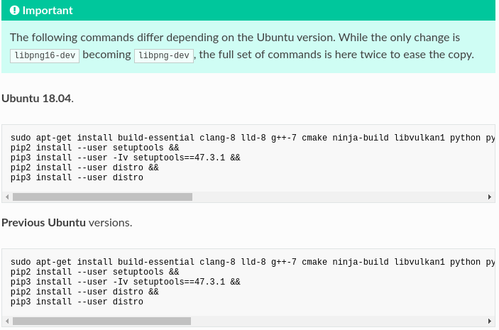

**Type this into your command line:**

sudo apt-get install build-essential clang-8 lld-8 g++-7 cmake ninja-build libvulkan1 python python-pip python-dev python3-dev python3-pip libpng-dev libtiff5-dev libjpeg-dev tzdata sed curl unzip autoconf libtool rsync libxml2-dev libxerces-c-dev

pip2 install --user setuptools &&

pip3 install --user -Iv setuptools==47.3.1 &&

pip2 install --user distro &&

pip3 install --user distro

**Break into sub-steps**(in my case):

autoconf

build-essential

**clang-8 (clang-10)**[**https://www.ubuntuupdates.org/package/core/focal/universe/base/clang-8**](https://www.ubuntuupdates.org/package/core/focal/universe/base/clang-8)

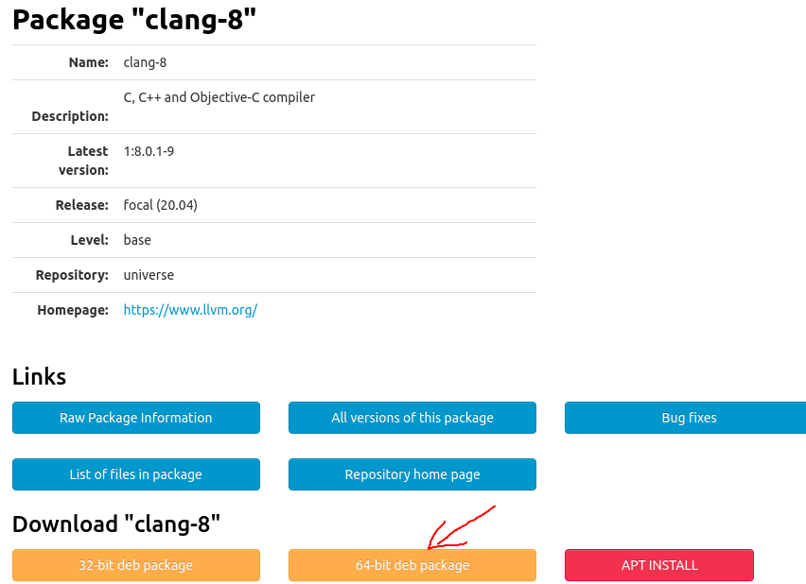

**sudo apt install ./clang-8_8.0.1-9_amd64.deb**

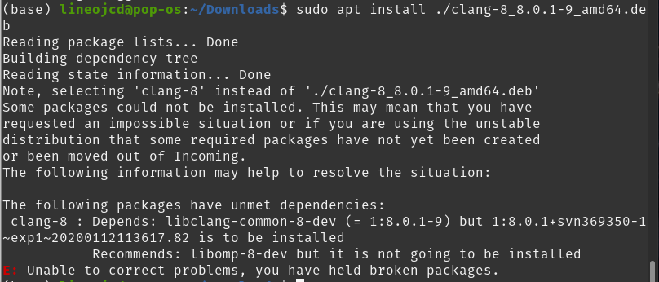

**sudo apt install llvm-8-dev=1:8.0.1-9**

**sudo apt install libllvm8=1:8.0.1-9**

**sudo apt install libclang-common-8-dev=1:8.0.1-9  
Be careful with clang-8, you have to make sure the dependencies version is met also.**

sudo apt install libomp-8-dev  
cmake  
curl   
g++-7 (g++-9)

https://lh6.googleusercontent.com/ashOgcVbY0MY-fEXw_W3hN8olBGKLol3pLmAcjhp8EaPykWDHL9d0Pg2R6vGozKMVsjJmmn2zW81yQTrRxp0sRe19l6nePDMeHEalbkwzsYn9IyNgo4YskqsLCY8g-KbX4VEEUho

libpng-dev

libtiff5-dev

libjpeg-dev

libvulkan1

libtool

libxml2-dev

libxerces-c-dev

**lld-8**

-A install libffi6 https://stackoverflow.com/questions/61875869/ubuntu-20-04-upgrade-python-missing-libffi-so-6

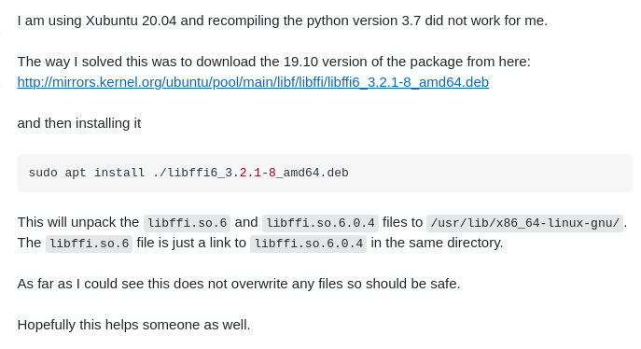

-B sudo apt-get install libllvm8

-C sudo apt-get install lld-8

ninja-build

python

**python-pip**

**How to Install Python Pip on Ubuntu 20.04**https://linuxize.com/post/how-to-install-pip-on-ubuntu-20.04/#installing-pip-for-python-2

python-dev

python3-dev

python3-pip

rsync

sed

tzdata

unzip

**Next:**

pip2 install --user setuptools &&

pip3 install --user -Iv setuptools==47.3.1 &&

pip2 install --user distro

pip3 install --user distro

To avoid compatibility issues between Unreal Engine and the CARLA dependencies, it is recommended to use the same compiler version and C++ runtime library to compile everything. The CARLA team uses clang-8 and LLVM's libc++. Change the default clang version to compile Unreal Engine and the CARLA dependencies.

sudo update-alternatives --install /usr/bin/clang++ clang++ /usr/lib/llvm-8/bin/clang++ 180 &&

sudo update-alternatives --install /usr/bin/clang clang /usr/lib/llvm-8/bin/clang 180

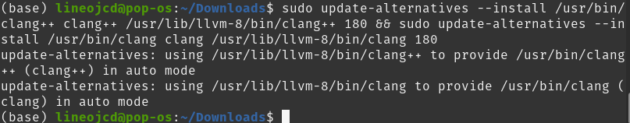

**-3 install git**

If you have done this step, just skip it.

**-4 Download Unreal**

The current version of CARLA runs on Unreal Engine 4.24 only. The path is irrelevant, but for the sake of this tutorial, installation will be done under **~/UnrealEngine_4.24**. If the path chosen differs, remember to change it accordingly when running the commands on terminal.

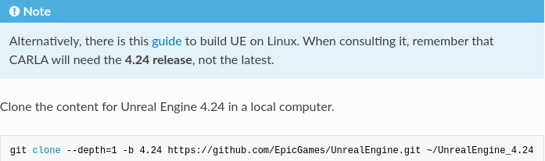

git clone --depth=1 -b 4.24 https://github.com/EpicGames/UnrealEngine.git ~/UnrealEngine_4.24

Get into said folder. Remember, this is the path where UE4.24 has been cloned.

cd ~/UnrealEngine_4.24

Get a patch for Unreal Engine. The patch fixes some Vulkan visualization issues that may occur when changing the map. Download and install it with the following commands.

wget https://carla-releases.s3.eu-west-3.amazonaws.com/Linux/UE_Patch/430667-13636743-patch.txt ~/430667-13636743-patch.txt

patch --strip=4 < ~/430667-13636743-patch.txt

Make the build.

./Setup.sh && ./GenerateProjectFiles.sh && make

when it ask you： *Register Unreal Engine file types*  I clicked Yes

when you see this means the building finish properly.  
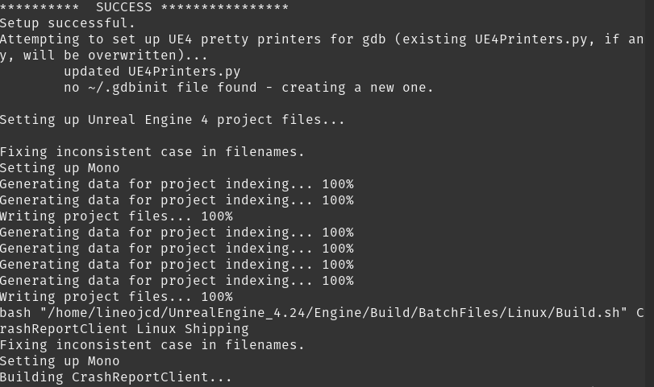

and the unreal is building now

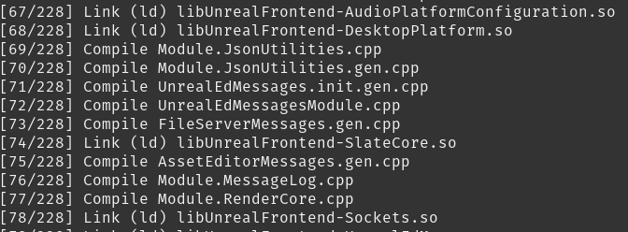

Finish building  
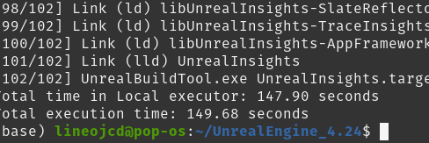

**-4 Check Unreal**

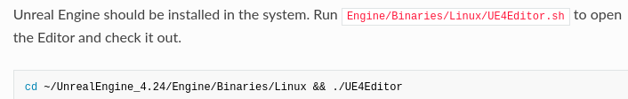

cd ~/UnrealEngine_4.24/Engine/Binaries/Linux   
./UE4Editor

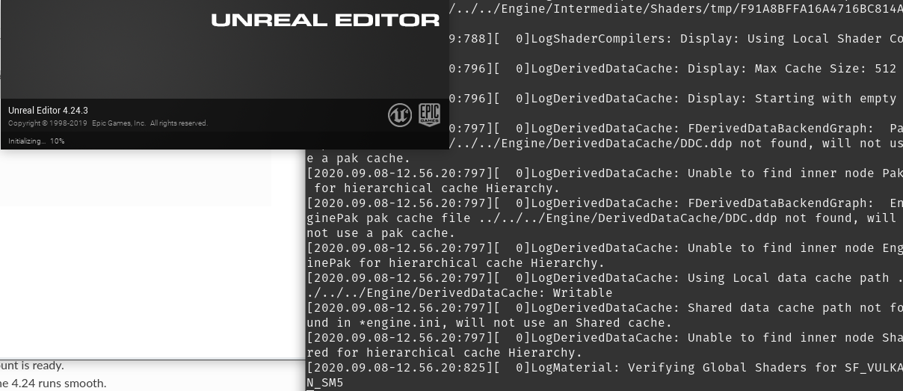

**Start it with a specific project**

https://github.com/EpicGames/UnrealEngine/blob/release/Engine/Build/BatchFiles/Linux/README.md

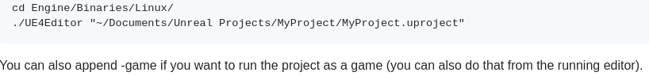

**-5 Build Carla**

https://lh5.googleusercontent.com/jr9nGv6urR-cFH_MnLjvQWWK_MtZDHgZTamTyDxRBct1bcOKXpmbzYlm9YvzEBNHcnvKzliuH0v7vj89bI2NSsyV2oGY5VkEzDkp0-PHd-etpxKLO-ldX-QROhm3-uAJ5Y6uc1vc

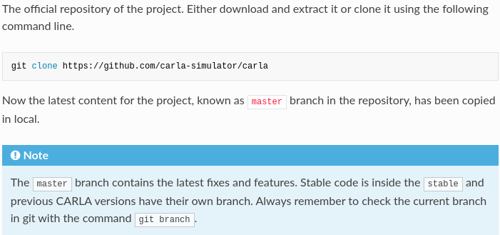

git clone <https://github.com/carla-simulator/carla>

**My folder structure:**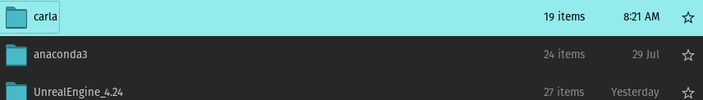

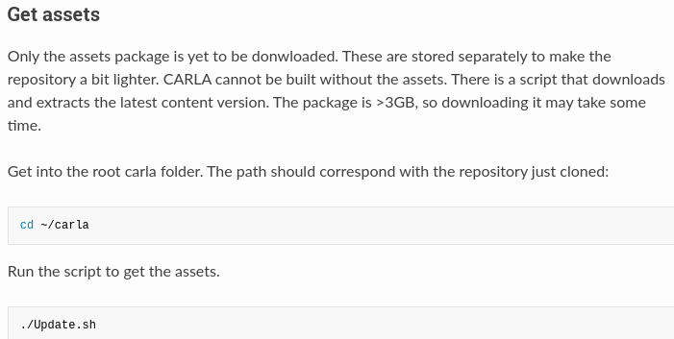

cd ~/carla

./Update.sh

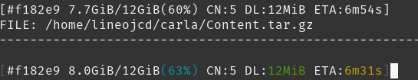

**Set the environment variable**

This is necessary for CARLA to find the Unreal Engine 4.24 installation folder.

export UE4_ROOT=~/UnrealEngine_4.24

https://lh5.googleusercontent.com/M0FD_kiaMalrs-GhdYahEGw6DB7yp3HWvUibY2xRw6H9K0GKInK2ljej_W2xjM_qjhv5sDMmY0yasEQeWAqO936H07RhX33QFWT9iu4L2j0F5y5DNVT7eESi4mkSNCf7q7iTNO2w

I use:

 echo 'export UE4_ROOT=~/UnrealEngine_4.24' >> ~/.bashrc

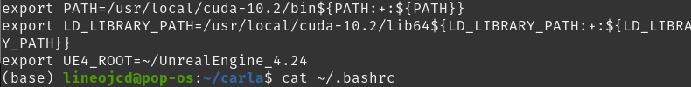

source ~/.bashrc

**make CARLA**

The last step is to finally build CARLA. There are different make commands to build the different modules. All of them run in the root CARLA folder.

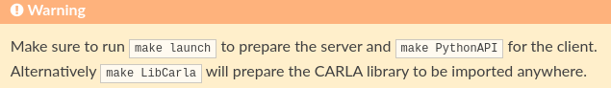

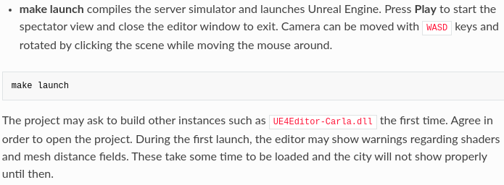

make launch

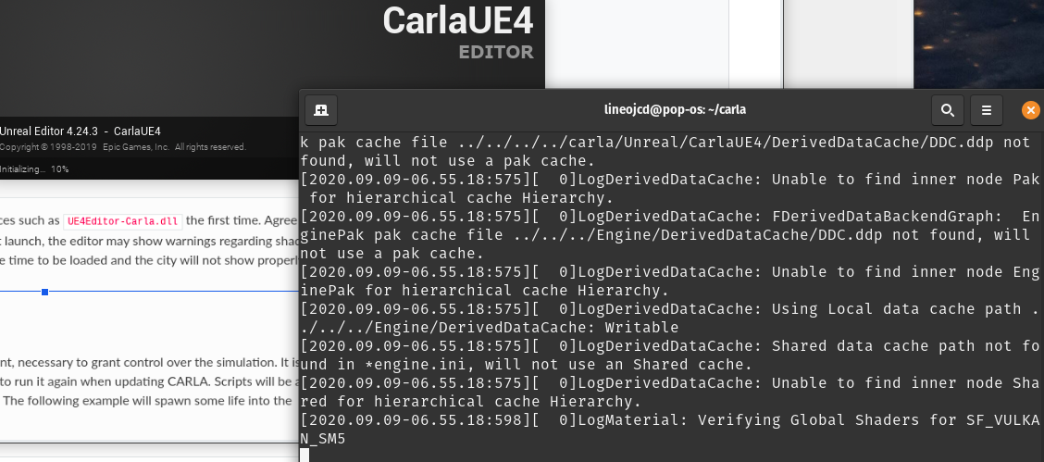

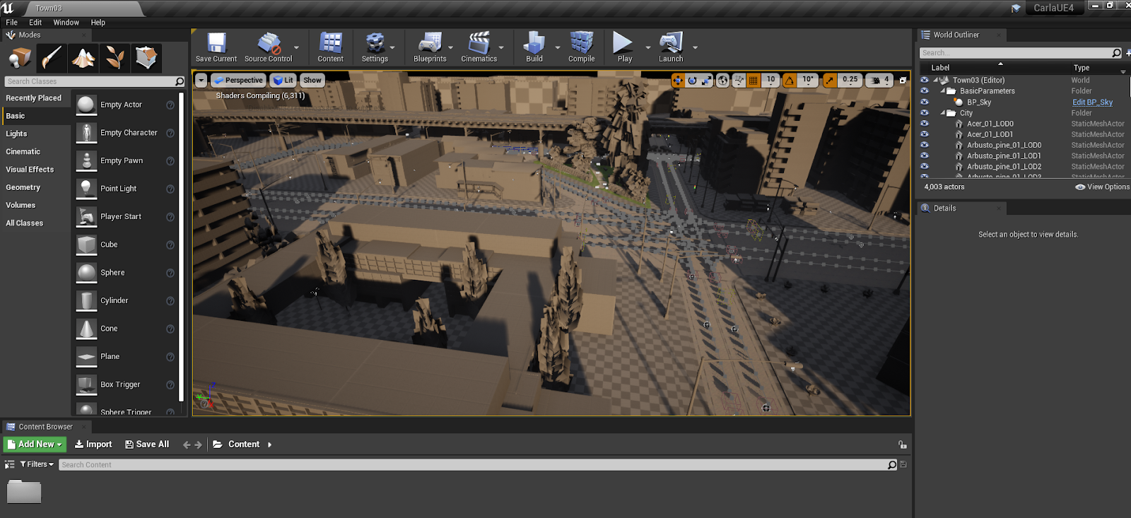

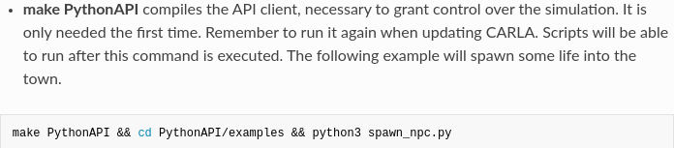

make PythonAPI

If you are using other linux system or a system based on ubuntu,it might cause errors:  
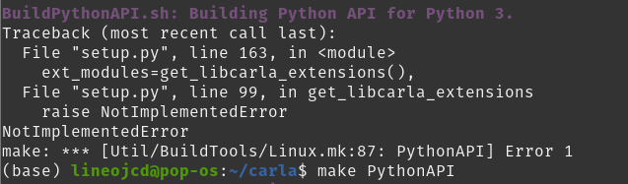

**How to solve?**

Mintlinux 19.3, Carla 0.9.7, Unrealengine 4.22, 'Make PythonAPI' failed #2344  
https://github.com/carla-simulator/carla/issues/2344

This is because:  your system distro is not in ["ubuntu", "debian", "deepin"]. In my system, the distro is **Pop!_OS**, simply manually specify it.

linux_distro = "ubuntu"

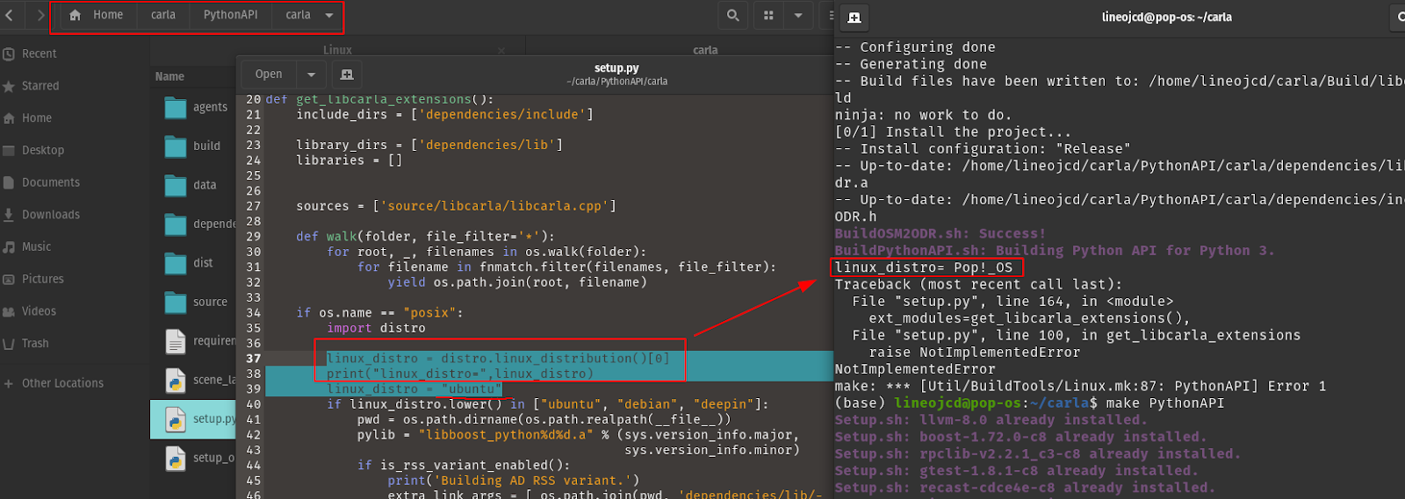

**Done!**

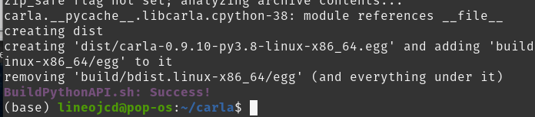

cd PythonAPI/examples && python3 spawn_npc.py

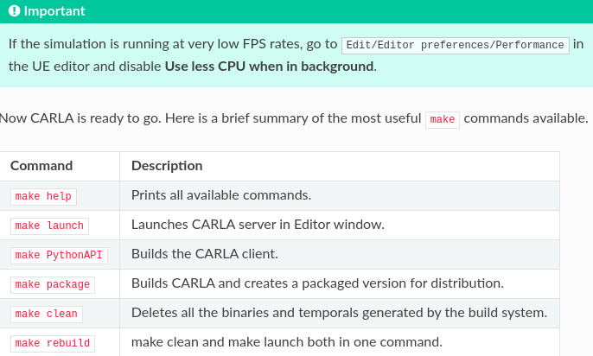

**how to run Carla with a Python client**

CARLA Tutorial 00 - Getting Started  
https://www.youtube.com/watch?v=AaJekfFR1KQ